Assignment 1 Report – Introduction to Linux Basic Commands
Student Name: Ufiteyezu Mpore Kevin
Student ID: 21831
Course: COSC 8312
Institution: Adventist University of Central Africa
Assignment: Introduction to Linux – Basic Commands
Due Date: September 23, 2025

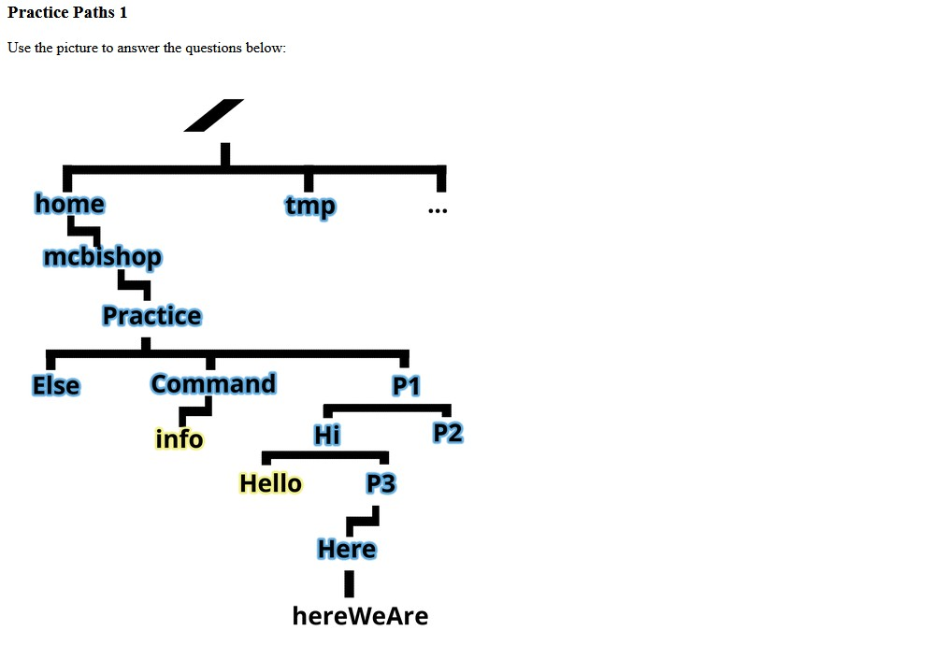
Linux Navigation & File Commands

Question 1: From P3 → Go to Home Directory

a) Using relative path
cd ../..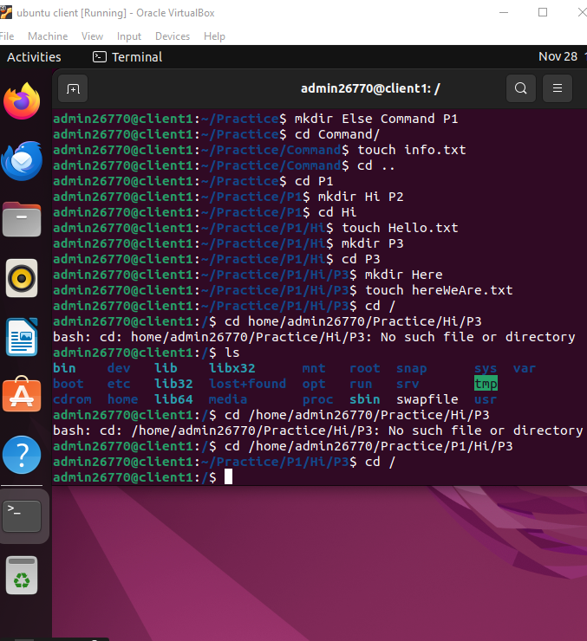

b) Using absolute path
cd /home/mcbishop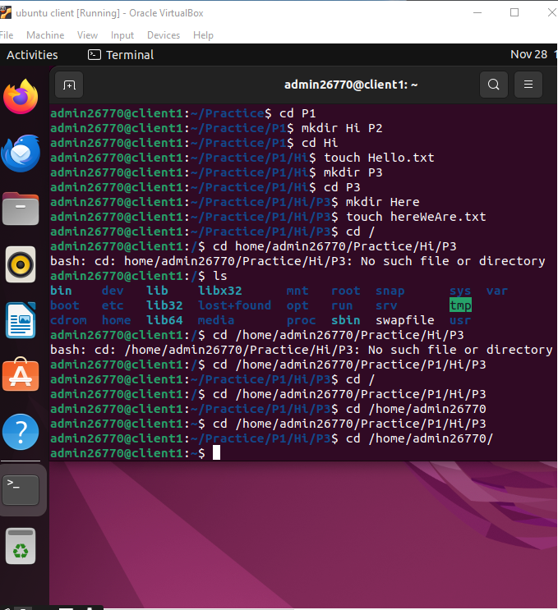

Question 2: Show a long listing of Here

a) From the Command directory (relative path)
ls -l Hello/P3/Here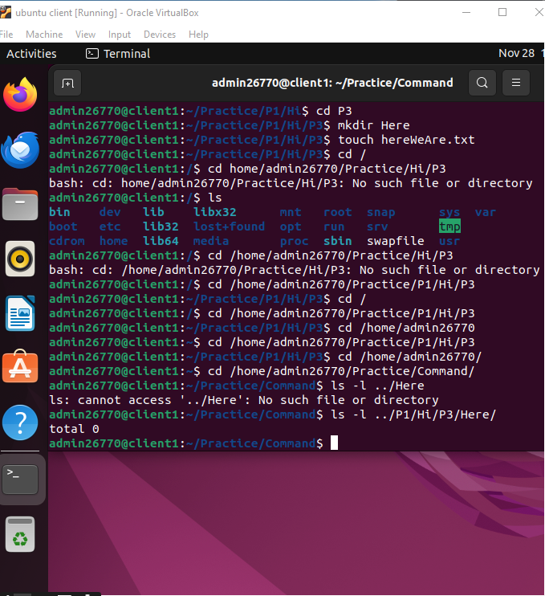

b) Using absolute path

ls -l /home/mcbishop/Practice/Command/Hello/P3/Here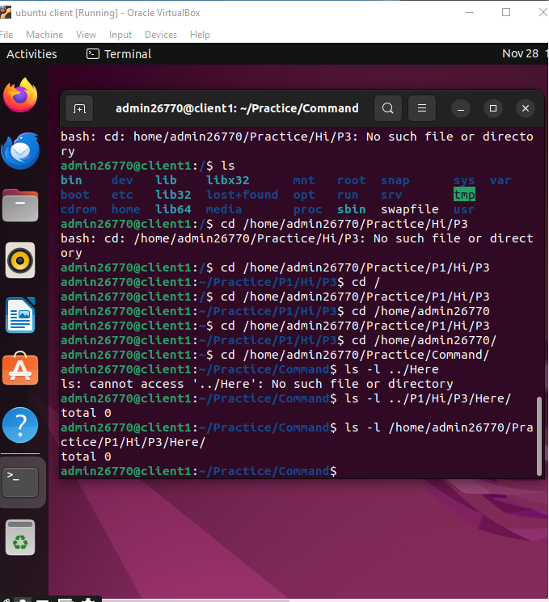

Question 3: Copy the file P3 to the Command directory
- From P2 directory (relative path)

cp ../home/mcbishop/Practice/Command/Hello/P3 Command/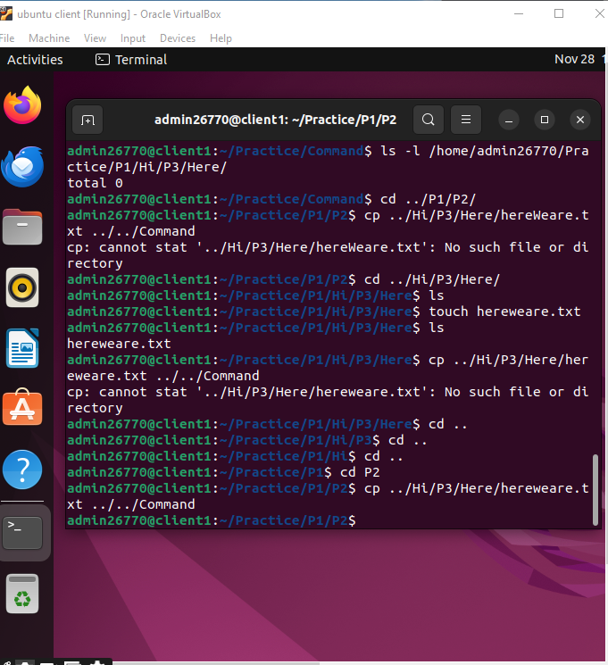

b) From P3 directory (relative path)

cp P3 ../../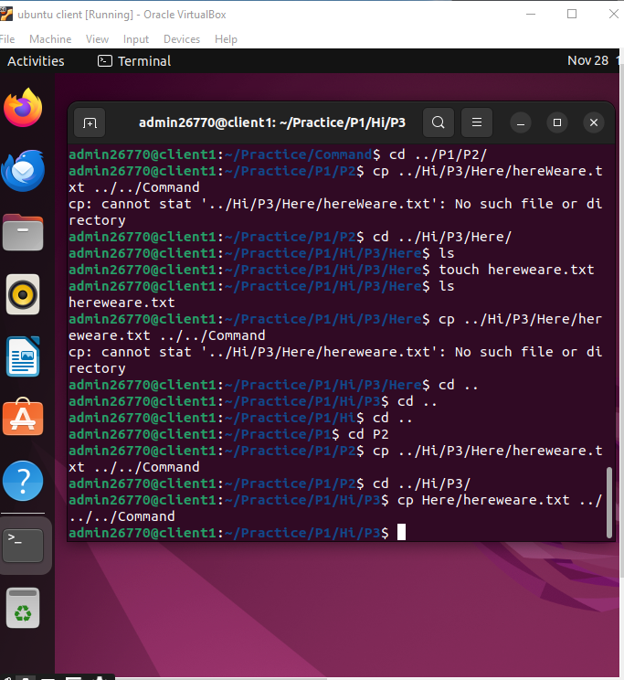cp ../P3 .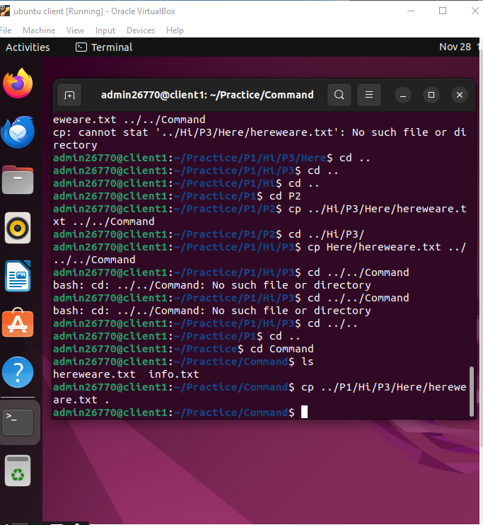

d) Using absolute path

cp /home/mcbishop/Practice/Command/Hello/P3 /home/mcbishop/Practice/Command/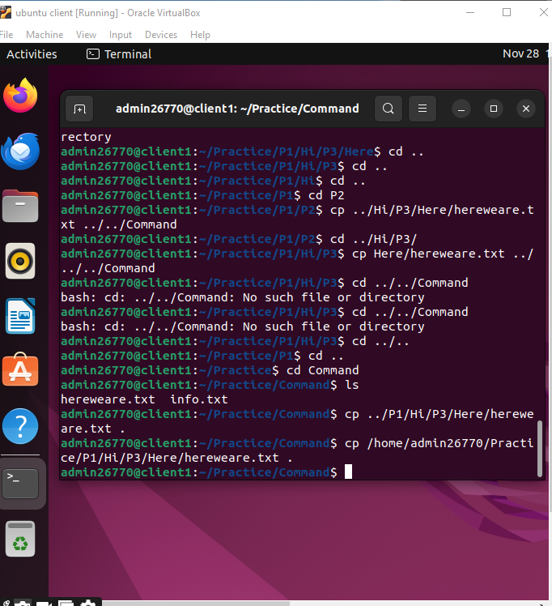

Question 4: Copy all files in P3 to Command directory
- From P2 directory (relative path)

cp ../home/mcbishop/Practice/Command/Hello/P3/* ../home/mcbishop/Practice/Command/

c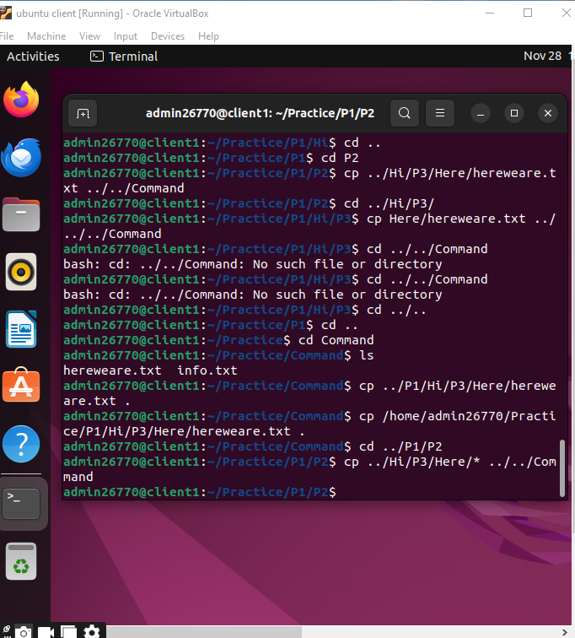

b) From P3 directory (relative path)
cp * ../Command/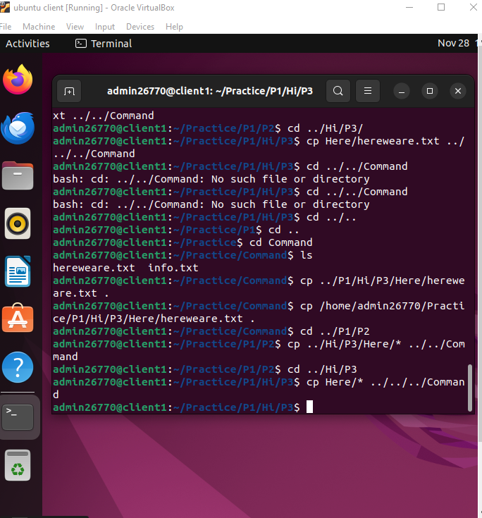

c) From Command directory
cp ../P3/* .
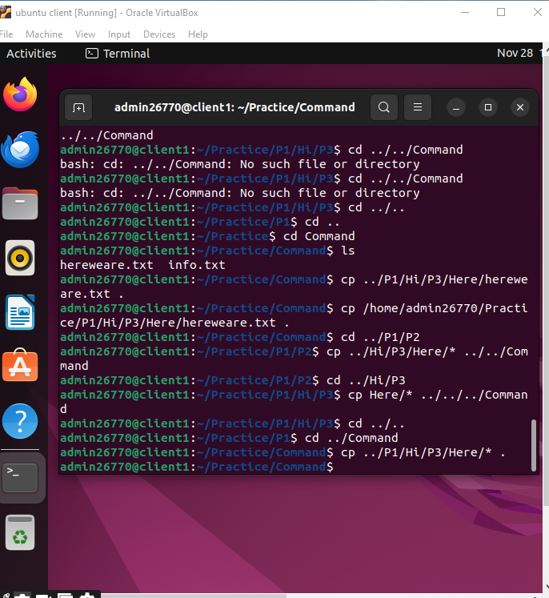

d) Using absolute path
cp /home/mcbishop/Practice/Command/Hello/P3/* /home/mcbishop/Practice/Command/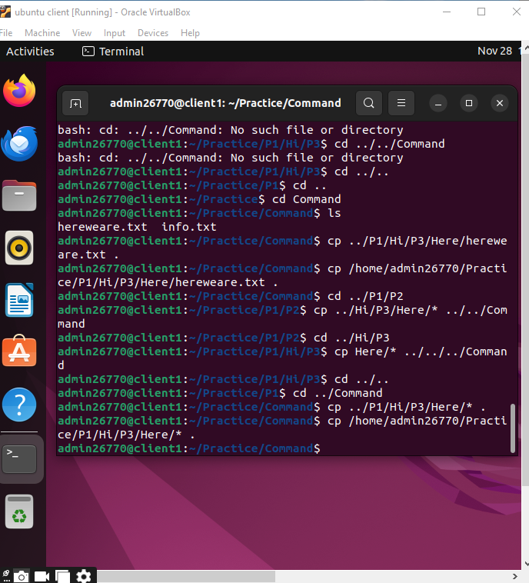

Question 5: Difference Between Q3 and Q4
- Question 3 copies one file named P3.
- Question 4 copies all the files inside the P3 directory.
So Q3 = single file, Q4 = multiple files from a folder.

Question 6: Meaning of Colors (Yellow, Blue) and Color of hereWeAre
Linux terminal color meanings:
Color | Meaning
Blue | Directory
Yellow | Executable file
Green | Normal file
Cyan (light blue) | Symbolic link

